

**Bravo Analytics Guide**

# Version History

|  |  |  |  |
| --- | --- | --- | --- |
| **Date** | **Document Version** | **Document Revision History** | **Document Author/Reviser** |
| **15th Jan 2019** | **1.0** | **Initial Draft** | **Prashant Erande** |
| **20th Jan 2019** | **1.1** | **Final** | **Asim Bagwan** |
|  |  |  |  |
|  |  |  |  |
|  |  |  |  |

Table of Contents

1 Version History 2

2 Document Objective 4

3 Pre – requisites 4

4 Bravo Analytics 5

4.1 Department Network Pulse 5

4.2 Interdepartmental Bravo Distribution 7

4.3 Value Wise Distribution of Bravos in Different Department 9

4.4 Participation by Employee 11

4.5 Gender Diversity Chart (Unique) 13

4.6 Gender Diversity Chart (according to value) 15

4.7 Bravos for Different Entity 19

4.8 People distribution for recognition frequency. 22

# Document Objective

This document has been created for the Clarification and Elaboration of the Graphs Present in the Bravo (BravoAnalytics).

# Pre – requisites

User need to have the Permissions on the Power Bi Portal.

# Bravo Analytics

## Department Network Pulse

This graph shows the department connection of the organization. And contain below sections.

* **Filter By Bravo Given Date**: - user can filter the connections depending on the bravo date so that user will get the how frequently departments are connected in the particular date/month period
* **Filter By Department**: - User can Filter the Connections depending on the department so the graph will be only related to that department.
* **Filter By Value**: - User can filter the connections for the particular Bravo value.

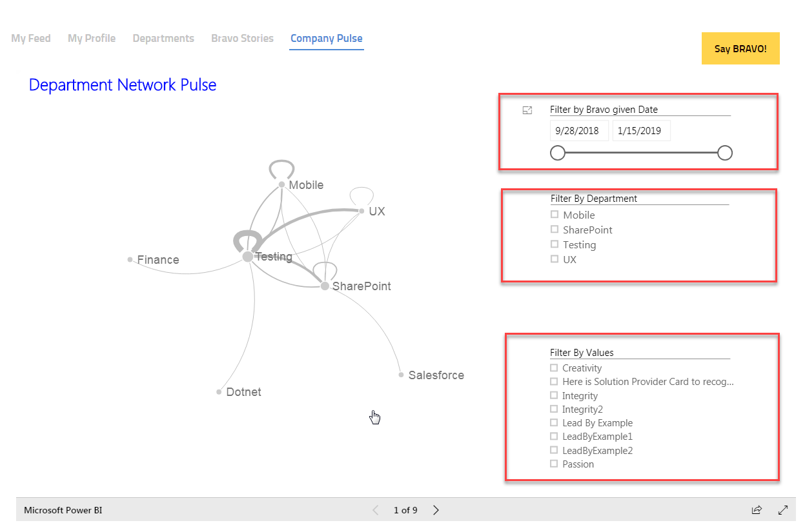

* **Network Pulse**: -
* Node will be appearing for department.

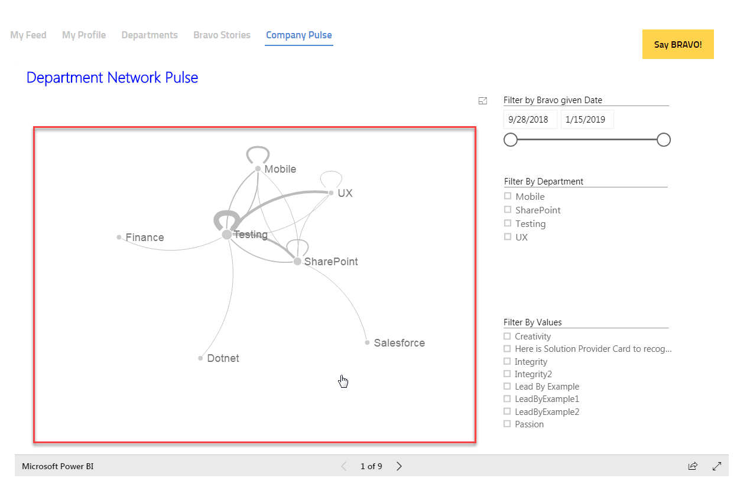

* + If bravo is given/received inside the same Department then it will show as
  + If bravo is given/Received for another department it will show as

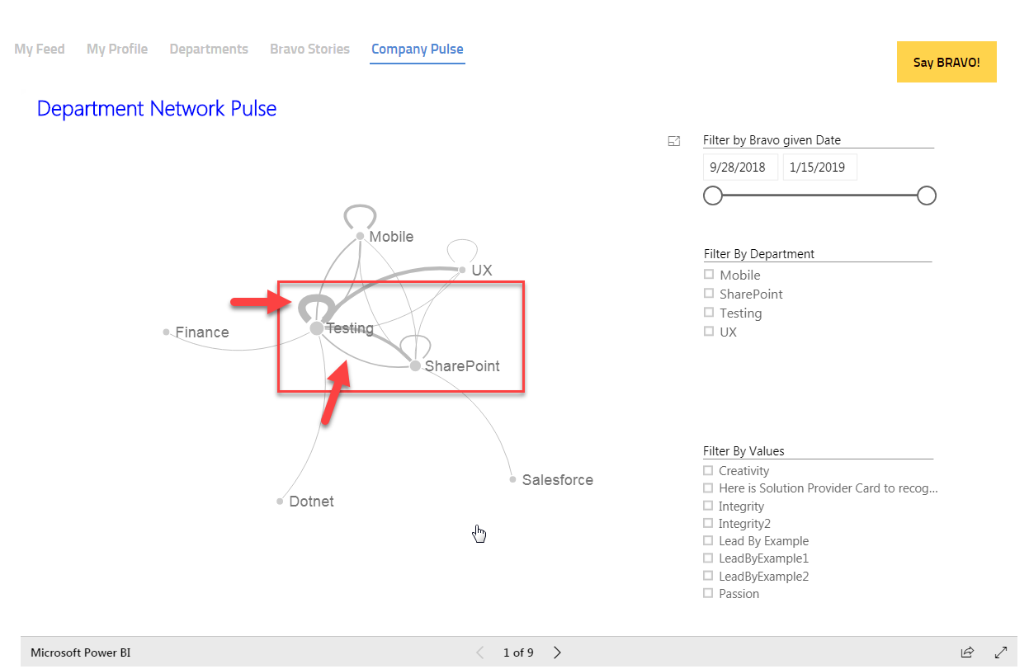

* On mouse over of the links it will give the details about the connection.as below

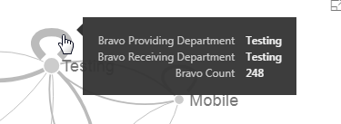

## Interdepartmental Bravo Distribution

This graph will show the Interdepartmental Distribution of the organization. And contain below sections.

* **Bravo Count:** - user can See the Total number of Bravo Count.
* **Bravo Receiving Department**: - User can Filter the Distribution depending on the department, so the graph will be only related to that department. And will show the Received count on it and on click of the department Providing department will be filtered and show which department is giving the Bravo for the Selected department.
* **Bravo Providing Department**: - User can Filter the Distribution depending on the department, so the graph will be only related to that department. And will show the Providing count on it and on click of the department Receiving department will be filtered and show which department is receiving the Bravo for the Selected department.

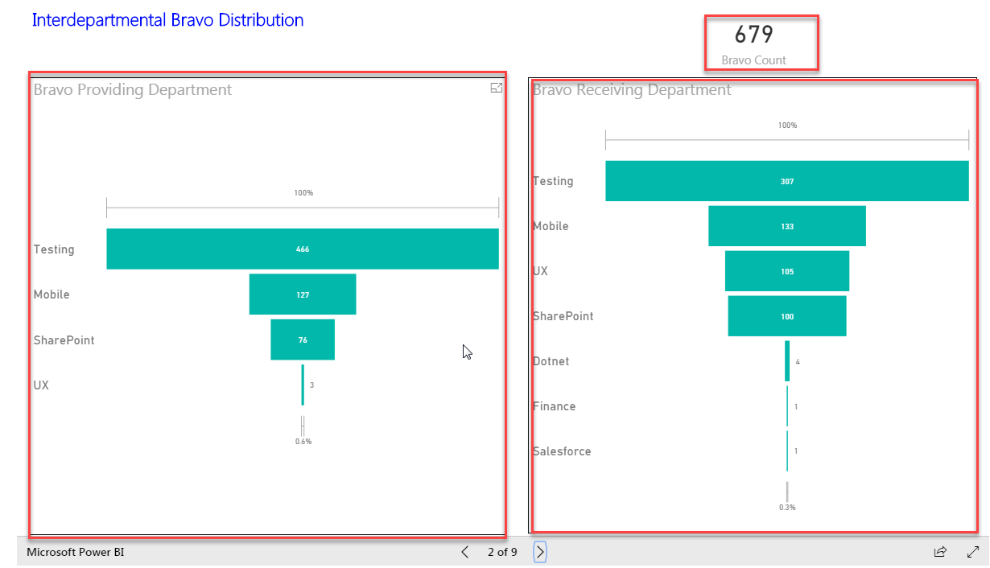

* **On mouse Over Of the department:** - It will show the details of “Providing/Receiving Department, Bravo Count, Percentage of First”.

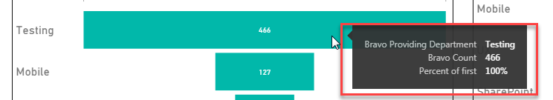

* **Lower Department Contribution/Distribution percentage will be According to /Respected to the First Department as first department Bravo count is Considered as 100%.**
* People who are not set to any department will be Filtered for the Providing/Receiving department section.

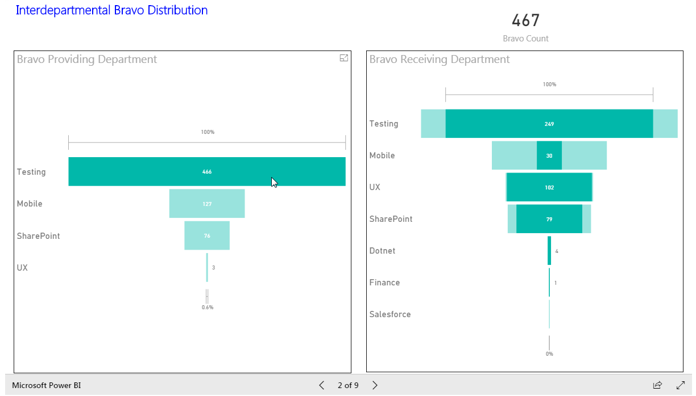

## Value Wise Distribution of Bravos in Different Department

This graph will show Value Wise distribution of Bravos. And contain below sections.

* **Bravo Count:** - user can See the Total number of Bravo Count.
* **Values**: - User can Filter the Wheel to get the contribution/Used of value card and on mouse over it will show “Value Name, Bravo Count”.
* **Department Wheel**: -User can see the Departments Using the cards/Values and their count and on click of department values used by department will be filtered.

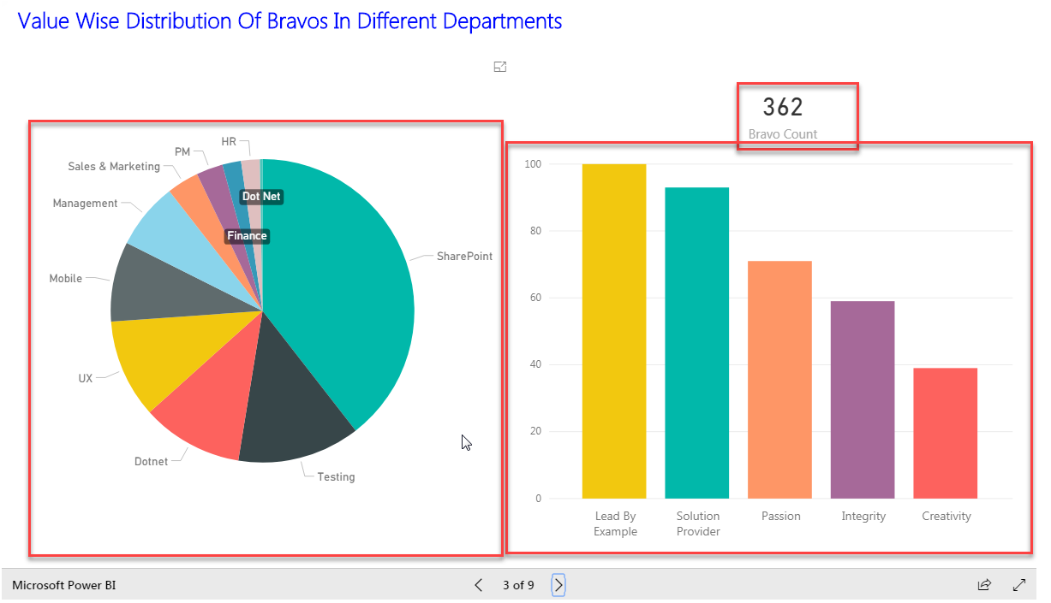

* on mouse over, it will show “Value Name, Bravo Count”.

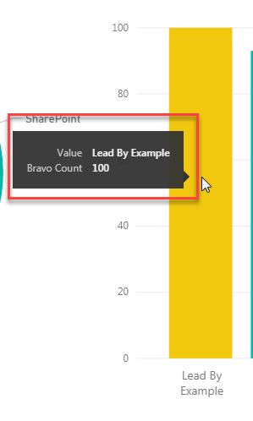

* on click of department values used by department will be filtered.

(Filled area will detail about the contribution/Use of Values)

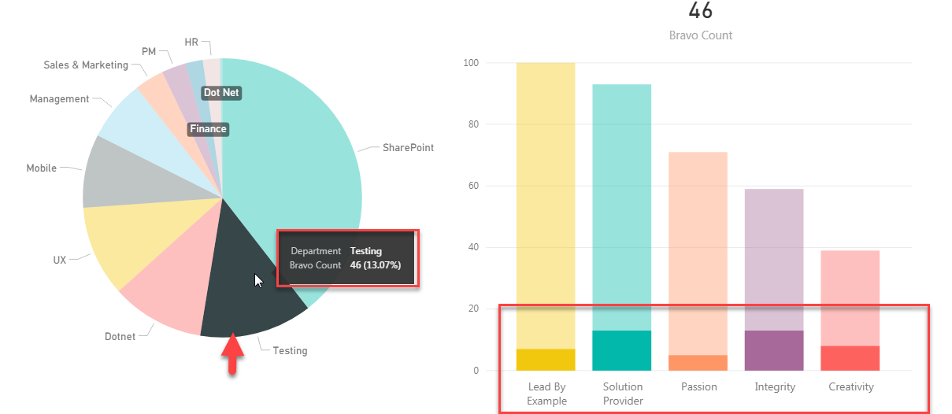

## Participation by Employee

This graph will show Participation of Employee in Bravo. And contain below sections.

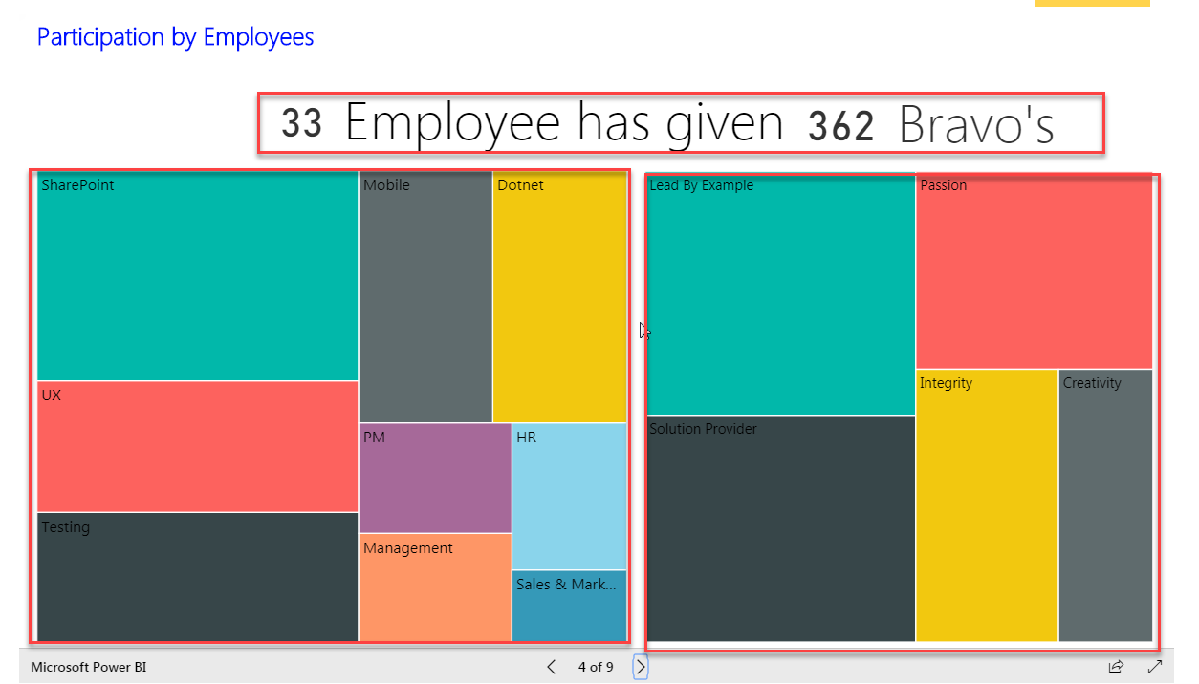

* Count of Employee and Bravo Provided by them.
* Departments Participating in Bravo.
* Values using by department while providing Bravo.
* **On Mouse Over** Of department: - It will detail about the Total number of Bravo Providing and Employee Participated to provide the Bravo.

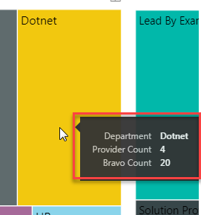

* **On selection of Department/Value: -** It will Filter the all the Values of Upper Line and show the line for Selected department. Values are filled with the Bravo count. And the chart will show the detail about selected department. And voice versa for values section.

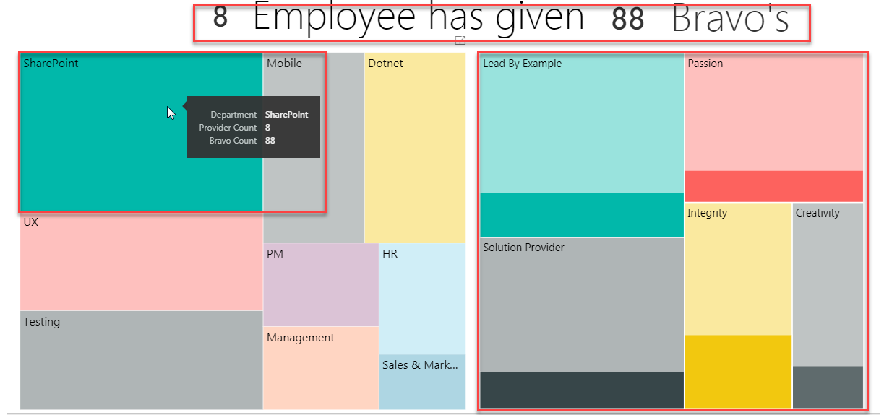

## Gender Diversity Chart (Unique)

This graph will detail the user about the How actively male and female are providing/Receiving the Bravo unique. And Contain below Sections

* **Bravo Count:** - user can See the Total number of Bravo Count.
* **Bravo Providing Gender: -** Will be showing the Organization male and Female participation while Providing the Bravo in the percentage.
* **Bravo Receiving Gender: -** Will be showing the Organization male and Female receiving the Bravo in the percentage.

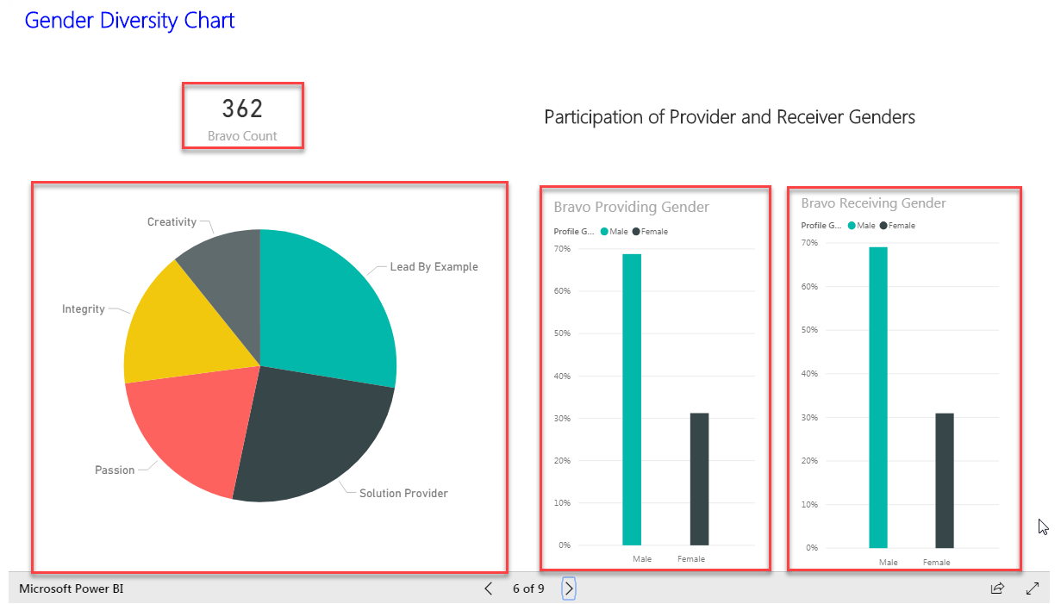

* **Value Wheel For filtration: -** Will be showing the Values and Bravo count. On section of the value Gender graphs will be filtered for the Selected value(Highlighted area will be showing the Genders using the graph for that value in percentage.).

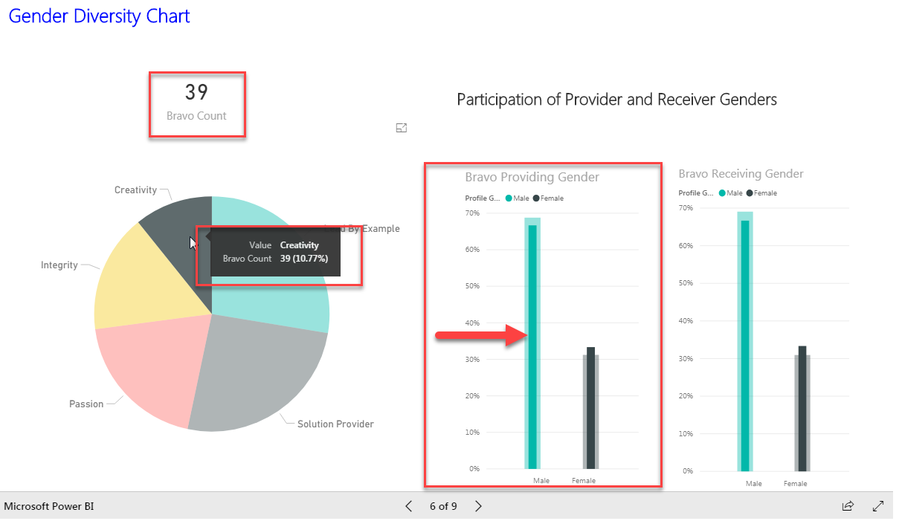

## Gender Diversity Chart (according to value)

This graph will detail the user about the How actively male and female are providing/Receiving the Bravo. And Contain below Sections

* **Bravo Providing: -** Will be showing the male and Female participation while Providing the Bravo in the percentage for the Values.
* **Bravo Receiving: -** Will be showing the male and Female receiving Bravo in the percentage for the Values.

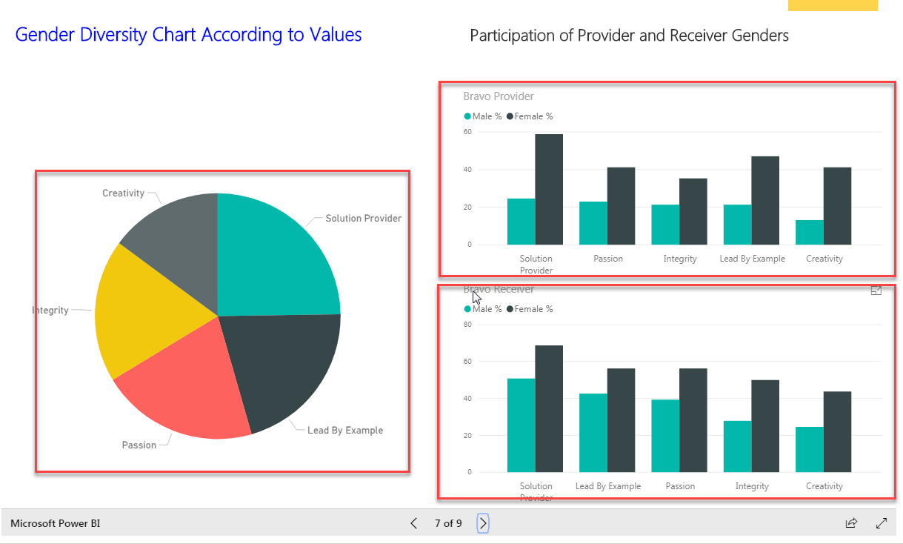

* **Value Wheel For filtration: -** Will be showing the Values and Bravo count. On section of the value Gender graphs will be filtered for the Selected value (Highlighted area will be showing the Genders using the graph for that value in percentage).

1. On selection **Bravo Providing Value** of the Value **Bravo Providing** will show the male and female Percentage using this card to provide the Bravo Out of Bravo given. And **Bravo Receiver** will show the people under the Providing section also getting Bravo of the Cards Values as below**.**

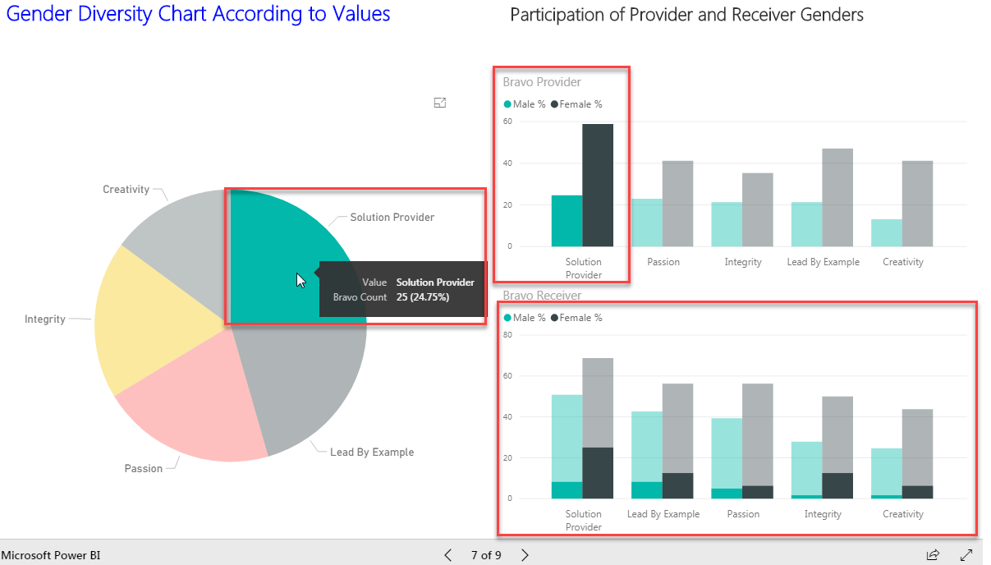

1. On selection of **Bravo Receiver Value,** the **Bravo Receiver** will show the male and female Percentage using this card to receive the Bravo Out of Bravo received. And **Bravo Provider** will show the people under the Receiving section also getting Bravo of the Cards Values as below**.**

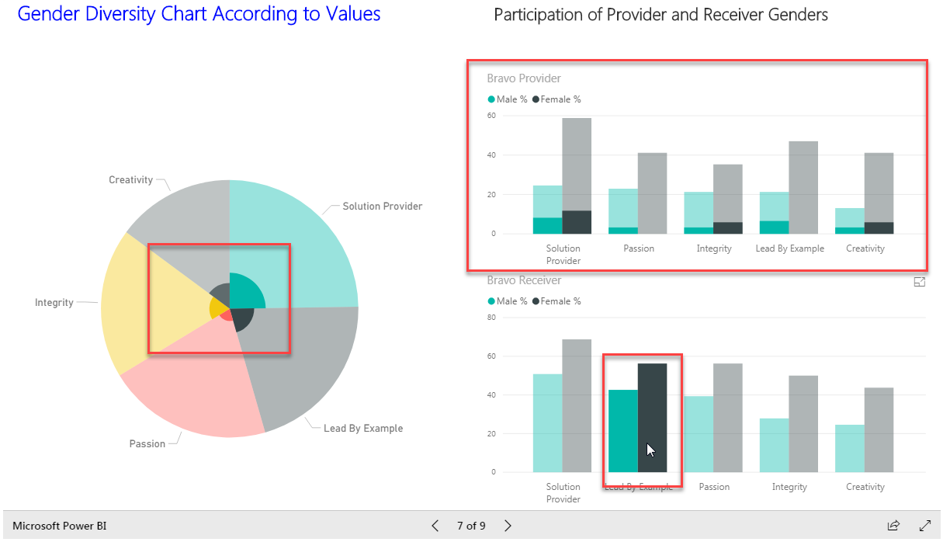

1. **On Mouse over** (Bravo Provider, Bravo Receiver, Value Wheel)**: -**

They will detail about the

**Bravo Provider: “Bravo Value and Percentage of Male/ Female”**

**Bravo Receiver: “Bravo Value and Percentage of Male /Female”**

**Value Wheel: “Bravo Value and Bravo Count”**

1. **On Selection of Value and Mouse over** (Bravo Provider, Bravo Receiver, Value Wheel)**: -**

They will detail about the

**Bravo Provider: “Bravo Value and Percentage of Male/ Female and Highlighted portion for selected value”**

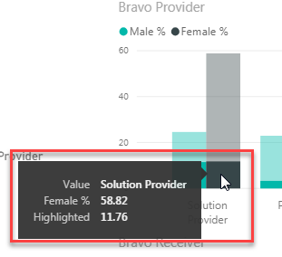

**Bravo Receiver: “Bravo Value and Percentage of Male /Female”**

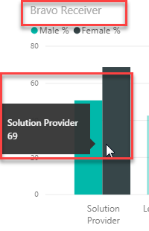

**Value Wheel: “Bravo Value and Bravo Count”**

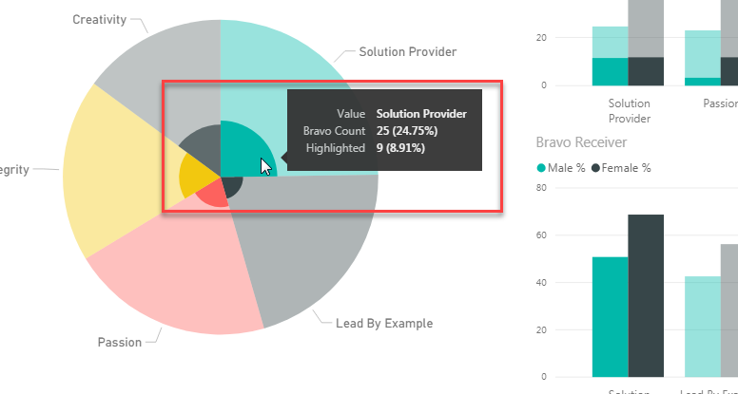

## Bravos for Different Entity

This graph will show the Entity details which are tagged in the bravo while providing the Bravo. And contain below sections.

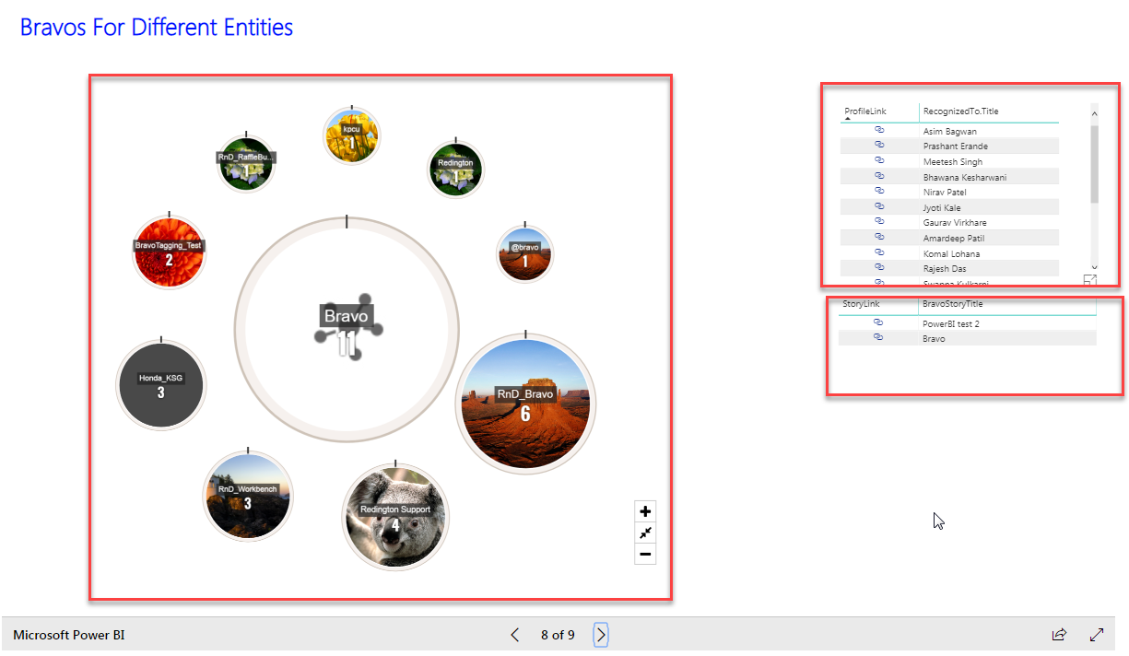

* **Bravo Entity tagged:** - user can See tagged Entity in the Bravo are appearing as **node Size of node is decided on the How many times the entity is tagged** in the Bravo. Bravo **Entity tagging Count will be shown on the node** with **Name and Entity Image on it**.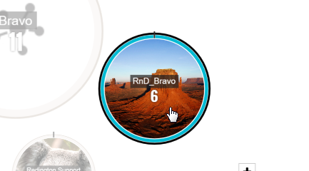
* **Stories Published with tagging this entity in it:** - user can See the Stories list and the **ReadStory** link with it if the Story is written and **the entity is tagged in it**.

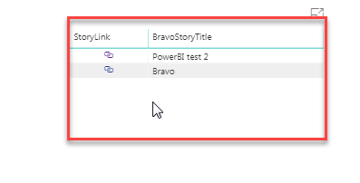

* **Profile to whom bravo is Providing while tagging Entity:** - User can see the details of people who is writing the story OR Receiving the Bravo and the “**ProfileLink**” option to view the Profile.

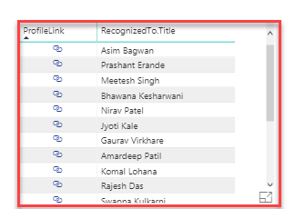

* **On selection of any Value:** - User can see the all the sections will be filtered for that particular values. And shoe the data related to that value only. As below

**(Ex: Selected “Prashant Erande” Tagged entity is marked as green and Stories are bold.)**

**On Click of “ProfileLink/ReadStory” you will redirect to that profile/Story in new tab.**

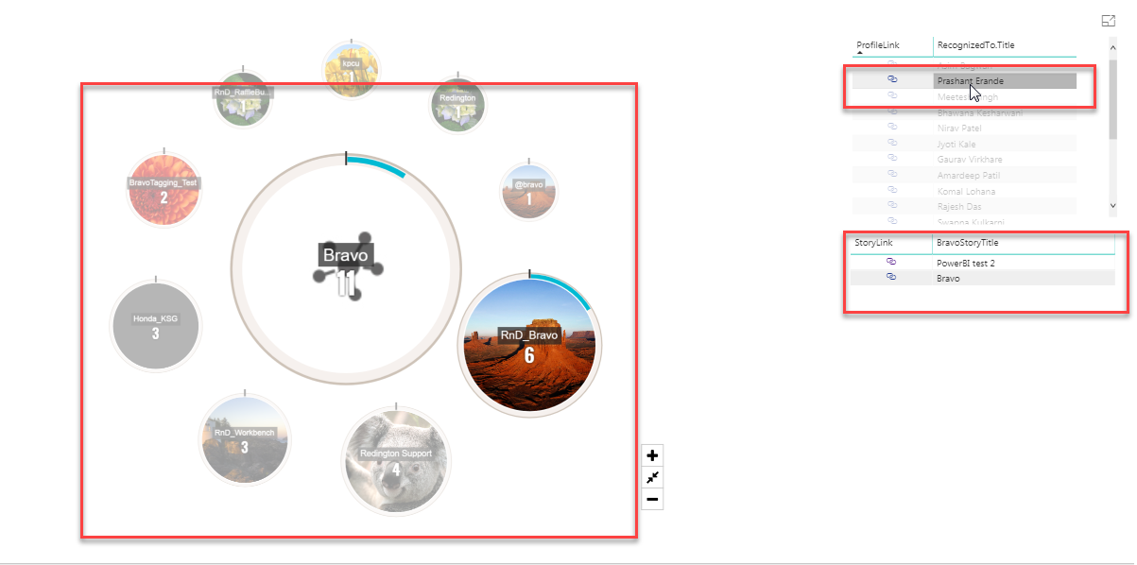

## People distribution for recognition frequency.

This graph will show People Distribution on their Bravo receiving frequency.

**On mouse Over**: -

* User Title
* Months
* Bravo Count
* Frequency
* Percentage of Frequency

**Conclusion**: -

**UPPER part**.

                        Blue – green line = Performing Good

                        Green – to red = doing good but can to Improve more

                         Above red = poor performance

**Lower part**.

                        Blue – green line = Performing Good

                        Green – to red = can be mishandling Bravo Or involved in lots of Bravos.

                         Above Red = mishandling Bravo.

               Max percentage of Occurrence is not getting Bravo. (Not receiving Bravo per month)

               Lower percentage is manipulating the colleges to give Bravo. (receiving lots of Bravo per month)

